The Inner Circle

Final Project Package- Engine Assembly

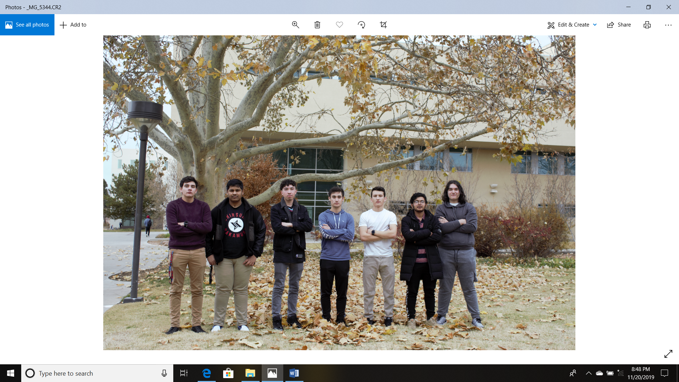

Figure 1: Pictured above, from left to right, Justice Otto, Anjan PN, Erik Morton, Jesse Garcia, Cameron Thomas, Bishwanath Bastola, Fabian Ortega

Presentation Date- 26 November 2019

Dr. Matthias Pleil

Rahul Adhikari

Fall 2019

Table of Contents

**Type chapter title (level 1)1**

Type chapter title (level 2)2

Type chapter title (level 3)3

**Type chapter title (level 1)4**

Type chapter title (level 2)5

Type chapter title (level 3)6

**Narrative**

For our project we decided to make a custom engine assembly known as a short block, based off of the Chevrolet big block 454. This consists of the engine block, crankshaft, connecting rods and pistons, along with several other parts such as nuts and bolts. By making a short block instead of a full engine, this allows us to engineer a high-performance assembly that can be customized by consumers to fit any specifications desired. With a short block, customers have freedom to equip any type of heads, exhaust, intake, fuel delivery, power adders and so on, so the engine can be geared to run on the street or the drag strip.

Our short block comes equipped with several extremely high-performance parts. The heart of the engine, the crankshaft, is a completely custom designed, forged 4340 steel beast that will be able to handle high rpms, high compression ratio, and last a very long time, even if it is used a quarter mile at a time. The customization of the crankshaft starts with an increased stroke, from stock four inches, to five inches, resulting in a huge increase in cubic inches of displacement in the motor. The next step was to take the original counterweight design of the crankshaft and knife-edge them, reducing weight and improving balance. Finally, by using a much stronger alloy of steel than stock, and forging rather than casting, the crankshaft’s strength and durability is increased.

Figure 2: Isometric view of Crankshaft

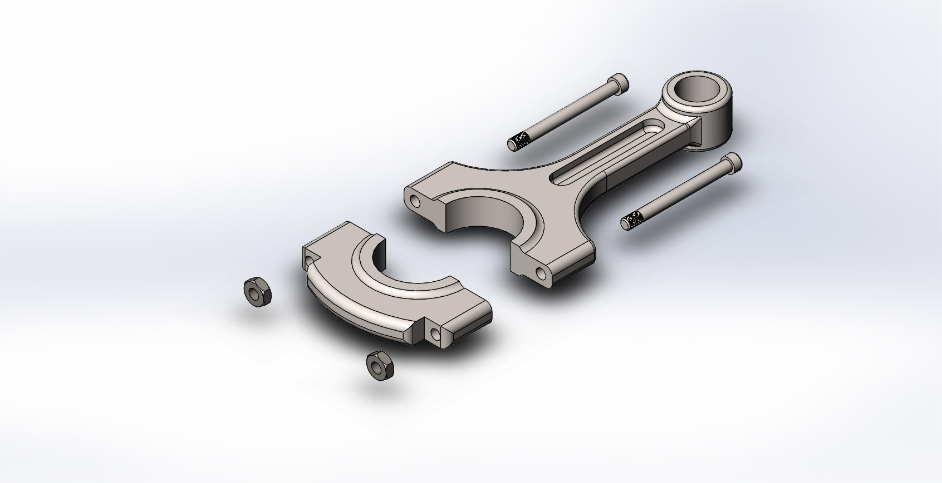 Next up we have the connecting rod assembly. Engine builders know that the connecting rods are usually the most stressed part in the entire engine, this is because their entire purpose is to connect the crankshaft to the pistons, but the process of moving in a rotary motion coupled with the explosive action of the pistons can easily brake a connecting rod once the engine starts to rev higher. To counter this, our connecting rods will be forged from titanium, so that ours will be able to withstand massive amounts of stress and punishment. By using titanium instead of the stock steel or cast iron, we reduce weight and improve strength, both features that are necessary to achieve higher rpms, thus improving horsepower. Our connecting rods also feature a slightly thicker base, which will also improve strength, while adding minimal weight. By having this unique design, our connecting rods will be able to handle the horsepower being produced by the rest of the engine.

Figure 3: Exploded View of Connecting Rod Assembly

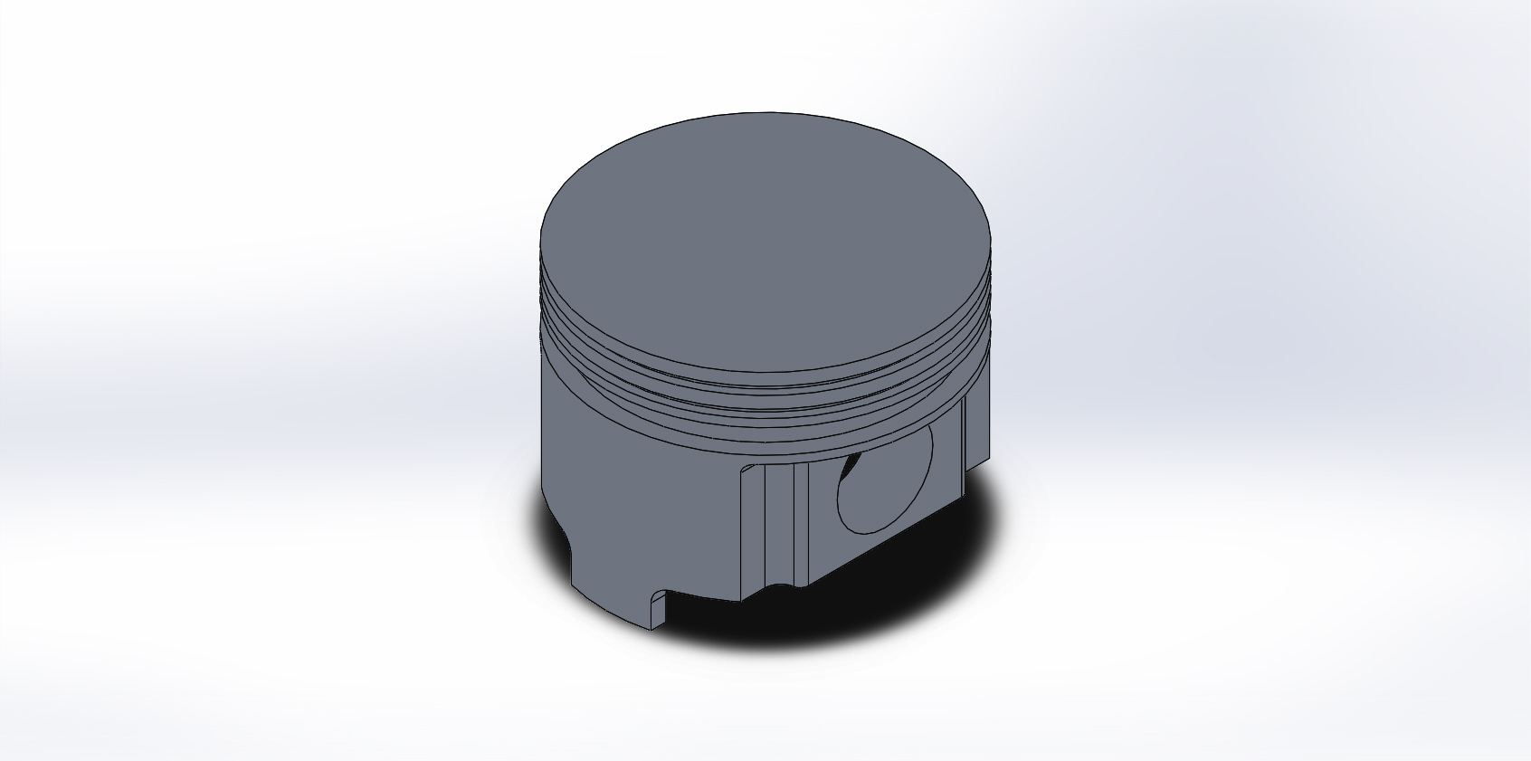 The pistons in any given engine have to be able to handle the combustion process. To do so they need to be very substantial, but also need to be light so that they aren’t stressing the connecting rods or the crankshaft, or just slowing down the rpms. To achieve both lightweight and durability, our pistons will be forged out of aluminum. Our pistons also feature completely flat machined tops for even combustion distribution in the cylinder, which results in maximum force and consistent performance.

Figure 4: Piston

Last, but definitely not least, we have designed a four-bolt main engine block that will be able to withstand any possible performance upgrade. Cast out of high-grade aluminum, this block is lightweight, durable and perfect for any build. Stock bore size is 4.25 inches, but our block will easily be able to withstand being machined up to a 4.5 inch bore if the buyer so desires. That means the stock displacement of this block is 567 cubic inches! With the maximum bore size that grows to an insane 636 cubic inches of displacement. Converted to liters, that’s a 10.4-liter engine. For comparison, the largest production engine in any car today is the Dodge Viper which has an 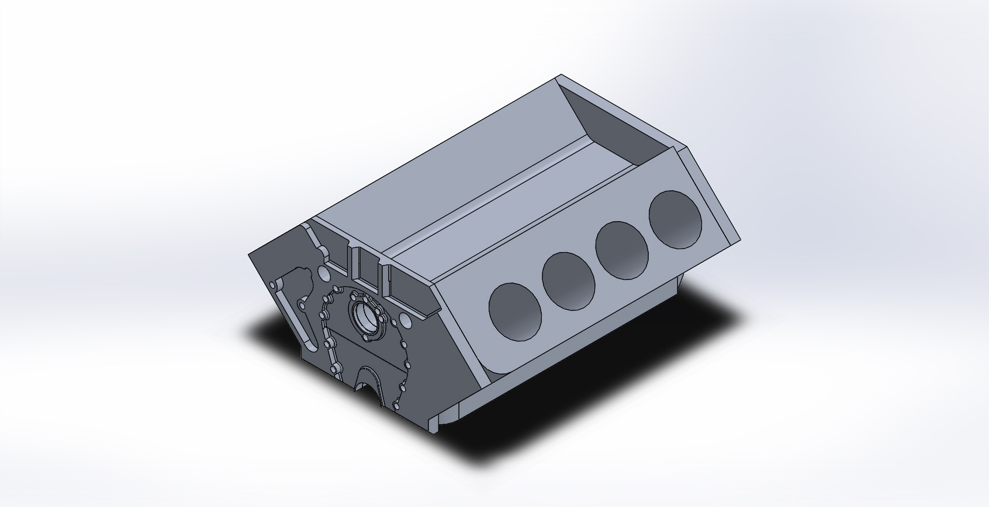8.0L (488 cubic inch) displacement V10 that puts out 645 base horse power. By increasing the amount of displacement and keeping our block a V8, this engine will easily put out that 1000 horse power mark. Pair this block with a set of 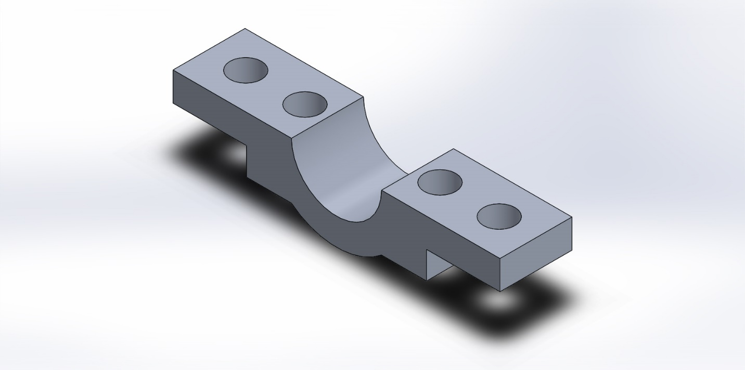aluminum heads, a blower and direct injection you can squeeze out enough horsepower to make supercar owners cry.

Figure 5: Engine Block

Figure 6: Main Cap

**Works Cited**

“Chevrolet Big-Block Engine.” Wikipedia, Wikimedia Foundation, 6 Nov. 2019, <https://en.wikipedia.org/wiki/Chevrolet_big-block_engine>.

“The Chevrolet Big Block V8 Engine.” The Novak Guide to The Chevrolet Big Block V8 Engine, <https://www.novak-adapt.com/knowledge/engines/about/chevy/chevy-big-block-v8/>.

Wilson, Tom. How to Rebuild Big-Block Chevy Engines. HP Books, 1983.

<https://www.novak-adapt.com/knowledge/engines/about/chevy/chevy-big-block-v8/>

Motortrend.com. “2017 Dodge Viper Reviews - Research Viper Prices & Specs.” Motor Trend, 21 Oct. 2019, <https://www.motortrend.com/cars/dodge/viper/2017/>.

“Find about Titanium Connecting Rods and Why Are They So Loved by Motorists.” Titanium Exposed, 23 Nov. 2019, <https://www.titaniumexposed.com/titanium-connecting-rods.html>.